2025 Single Family Rental West Christmas at the Princess FAQ’s

Christmas at the Princess is a family-friendly event at The Fairmont Scottsdale Princess. The hotel grounds transform into a dreamy Christmas scene with lights, Christmas characters, holiday food and entertainment for the whole family.

# Guest Staying Overnight on Property:

Overnight guests will receive complimentary nightly admission to the Christmas at the Princess festival and will be provided with VIP wristbands to use the Express Lanes. VIP Express Lane is available for overnight resort guests to reduce wait times at our rides and attractions (excluding ice skating, photos with Santa). VIP Express Wristbands cannot be purchased and are for guests staying overnight.

# Guests Staying off Property:

Please note that wristbands are required to enter any of the Christmas at the Princess activations. Christmas at the Princess tickets can be purchased at <https://www.christmasattheprincess.com/>

# What is included in Christmas at the Princess Wristbands?

Enchanted Plaza Show

Letters to Santa

Spectacular Light Displays

Starlights – An Electric Symphony Light Show

Princess Express Train Ride

The Village - Snow Mountain Ice Slide, Chair Lift, Nordic Nine Mini Golf

S’moresland at The Village

Twinkle Town

Winterland

# On Property Dining:

On property dining experiences high demand throughout the holiday season. We recommend reservations be booked one month prior to your visit. Please use the below links to reserve a table at Bourbon Steak, La Hacienda or Toro.

*Bourbon Steak:* <https://www.sevenrooms.com/reservations/bourbonsteakscottsdale/sfrf>

*La Hacienda:* <https://www.sevenrooms.com/reservations/lahacienda/sfrf>

*Toro:* <https://www.scottsdaleprincess.com/scottsdale-restaurants/toro>

# Event Pricing Online – <https://www.christmasattheprincess.com/>

# Self-Parking – $35 per car

# Valet Parking – $120 Per car

# General Admission - $35 per person

# Event Pricing Onsite Day Of

# Self-Parking – $45 per car

# Valet Parking – $130 Per car

# General Admission - $45 per person

# Arriving/Departing Resort via Rideshare:

Rideshare pick up and drop off will be at the designated Rideshare location just before the main arrival entrance to the hotel. Please inform your driver to arrive to the resort on Princess Drive via ***Hayden Road*** and keep their eye out for the event rideshare signage. Please refer to the map below.

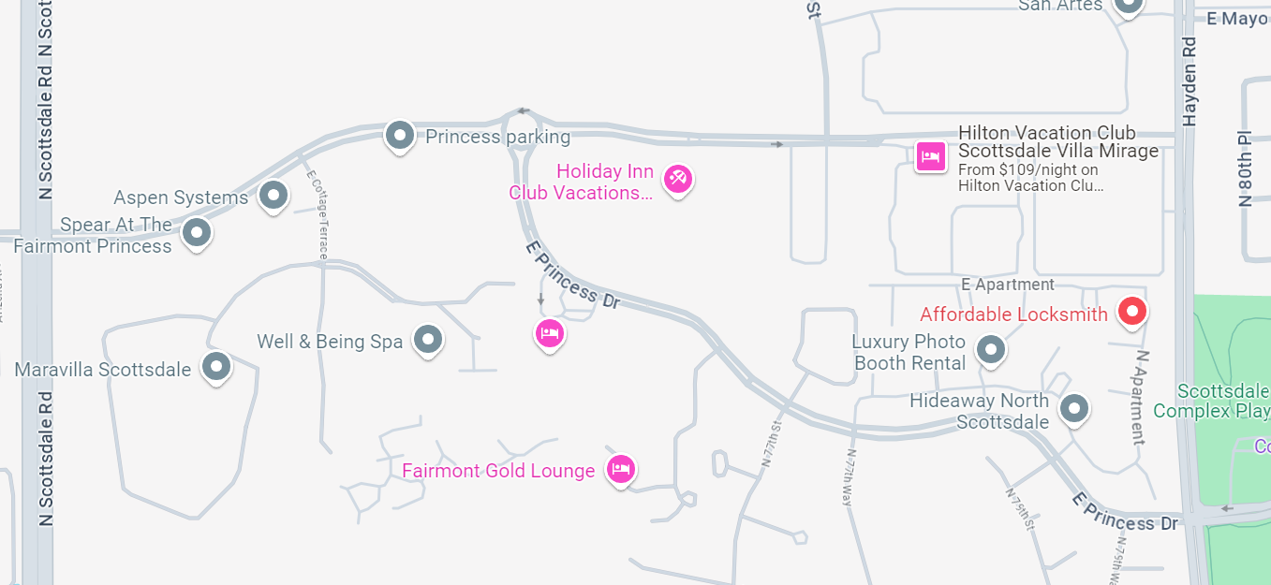

# Arriving/Departing Christmas at the Princess General Admission:

Christmas at the Princess Self-Parking will be at the Palomino Parking Lot. This lot is located on the South side of Princess Dr. Please inform your driver to arrive to the resort on Princess Blvd. via ***Scottsdale Rd*** and keep their eye out for the event self-parking signage. Please refer to the map below.

# Arriving/Departing Christmas at the Princess Valet & Hotel Guest:

Hotel Guest and Valet parking please arrive to the main arrival entrance to the hotel. Please inform your driver to arrive to the resort on Princess Drive via ***Scottsdale Rd*** and keep their eye out for the event hotel guest and valet signage. Please refer to the map below.

