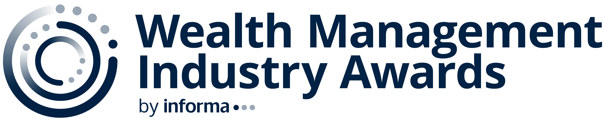
2026 Program
INITIATIVES
Nomination Categories/Subcategories: 100

New category for 2025

ASSET MANAGERS
- Alternative Investments
- Client Experience Initiative
- Digital Marketing Campaign of the Year
- Direct Indexing
- ETFs
- Fixed Income
- Goals-based Investing Platforms
- Models Portfolio Selection
- New Product Development
- Portfolio Construction
- Real Estate (including REITs)
- Separate Accounts
- Thought Leadership

BROKERS/DEALERS (1,000 Advisors or More)
- Digital Marketing Campaign of the Year
- Practice Management
- Service
- Technology
- Thought Leadership
- Transition Support

BROKERS/DEALERS (Fewer Than 1,000 Advisors)
- Digital Marketing Campaign of the Year
- Practice Management
- Service
- Technology
- Thought Leadership
- Transition Support

COMPLIANCE/LAW FIRMS

CORPORATE SOCIAL RESPONSIBILITY

CUSTODIANS
- Alternative Asset
- Digital Marketing Campaign of the Year
- Practice Management
- Technology
- Thought Leadership
- Transition Support

DISTRUPTORS
- Industry
- Technology

DIVERSITY, EQUITY AND INCLUSION

ENTERPRISE INNOVATION

ESTATE PLANNING
- Advisor Service and Support
- Implementation
- Technology
- Thought Leadership
- Trusts

FAMILY OFFICES
- Client Initiative
- Thought Leadership

INDIVIDUAL RIA FIRMS
- Client Initiatives

INDUSTRY ASSOCIATIONS

INDUSTRY RESEARCH PROVIDERS

INSURANCE

M&A DEAL SUPPORT

MARKETING/PR FIRMS
- Client Digital Campaign of the Year
- Client PR Campaign of the Year

PHILANTHROPY

PODCASTS
- Industry Focused
- Investor Focused

RECRUITERS
- Independent Recruiting Firm of the Year

RETIREMENT INCOME

RETIREMENT PLAN SUPPORT AND ADVISOR SERVICES
- 401(k) Technology
- Advisor Support: Aggregators
- Advisor Support: Broker-Dealers
- Advisor Support: DCIO Providers
- Advisor Support: Recordkeepers
- Advisor Support: Third Party Administrators
- Convergence – Wealth and Retirement Integration

TAMPs
- Model Marketplaces
- TAMPs

TECHNOLOGY PROVIDERS
- Account Aggregation
- Advisor Intelligence Platforms
- Alternative Investment Platforms
- Artificial Intelligence: Marketing and Lead Generation
- Artificial Intelligence: Meeting Support
- Artificial Intelligence: Workflow Automation
- Business Support Systems
- Cash Optimization
- Client Onboarding/New Account Opening
- Client Portals
- Compliance
- CRM
- Cyber Security
- Data Lakes/Warehouses
- Digital Marketing Campaign of the Year
- Direct Indexing
- Document Management
- Financial Planning
- Innovation New Applications
- Innovation Platforms
- Marketing Automation
- Model Marketplaces
- Outsourcing Platforms (Wealth as a Service)
- Portfolio Analytics
- Portfolio Management, Accounting and Performance Reporting
- Rebalancing
- Retirement Income Technology
- Risk Tolerance/Client Profiling
- Securities-based Lending
- Specialized Planning Applications
- Thought Leadership
- Unified (all-in-one) Systems

UNIVERSITY CFP PROGRAMS

VIDEO SERIES

