LAST DAY TO RECEIVE ADVANCE RATE IS 26 AUGUST 2025
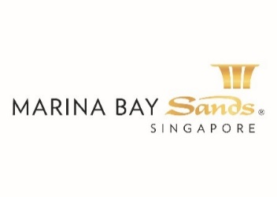 | DIGITAL PRINTING ORDER FORM - 2025  E-mail or fax forms to:  MARINA BAY SANDS PTE LTD – ATTN: SANDS EXPO & CONVENTION CENTRE – CUSTOMER SERVICE CENTRE  10 BAYFRONT AVENUE SINGAPORE 018956  P: +65 6688 3888 F: +65 6688 3889 E: secc@marinabaysands.com  Please indicate total number of pages faxed to ensure complete order was received.
EVENT NAME: ASIA BIO 2025 (83022) |  |  | EVENT DATES: 9-10 SEPTEMBER 2025 |  |  |  | BOOTH # / MTG. ROOM #
 |  |  | HALL LOCATION: L3 CASSIA BALLROOM |  |  |  | BOOTH # / MTG. ROOM #
EXHIBITING CO. NAME:

EXHIBITING CO. ADDRESS: (STREET) |  | (CITY) |  | (STATE) | (COUNTRY) |  | (ZIP CODE)
TELEPHONE: |  | FAX: |  |  |  | E-MAIL:
ORDERED BY: (DR/HON/PROF/MDM/MISS/MRS/MS/MR)  (Print Name) |  | JOB TITLE: |  |  |  | SIGNATURE:
BILL-TO CO. NAME: (If different from above)

BILL-TO ADDRESS: (STREET) |  | (CITY) |  | (STATE) | (COUNTRY) |  | (ZIP CODE)
TELEPHONE: |  | FAX: |  |  |  | E-MAIL:
ORDERED BY: (DR/HON/PROF/MDM/MISS/MRS/MS/MR)  (Print Name) |  | JOB TITLE: |  |  |  | SIGNATURE:
IMPORTANT: TO RECEIVE ADVANCE RATES (UNLESS OTHERWISE STATED) SANDS EVENT SERVICES MUST RECEIVE YOUR ORDER WITH FULL PAYMENT BY 5 PM SGT 14 CALENDAR DAYS PRIOR TO SHOW OPENING DATE TO ENSURE AVAILABILITY. Full payment must be included to receive advance rates, unless otherwise stated. payment received after the cut-off will be invoiced at the standard rate where applicable. ALL OTHER ORDERS WILL BE PROCESSED AT THE STANDARD RATE. NO CREDITS/REFUND WILL BE ISSUED ON SERVICES INSTALLED AS ORDERED EVEN THOUGH NOT USED. ALL ORDERS ARE SUBJECT TO A 7% GST & CANCELLATION FEE. REVIEW INVOICE PRIOR TO DEPARTURE.

DESCRIPTION | QTY | ADVANCE RATE | STANDARD RATE | SUBTOTAL
MISCELLANEOUS
Digital print on system panel per piece 950mm W x 2380mm H (Direct Mount) – per panel |  | $225 | $375
Digital print on compressed foam of 1000mm W x 2500mm H – per panel |  | $375 | $635
Digital print logo on fascia of maximum 3000mm W x 210mm H |  | $100 | $170
Digital print logo on Max reception desk of 920mm W x 660mm H |  | $100 | $170
Digital print on compressed foam |  | $150/sqm | $265/sqm
Digital print (direct mount) |  | $130/sqm | $215/sqm
Note: All artwork to be provided by client must be in high resolution file formats - EPS, AI or PDF. | Total
 | PREVAILING GST %
GRAND TOTAL (SINGAPORE DOLLARS)
Price Payable may be subject to change due to impending change in the GST Rate
All orders are subject to a cancellation fee if CANCELLED within 7 calendar days prior to show opening date. All prices are subject to change without prior notice.

PAYMENT MODE Credit card information will be used to guarantee the service request on this order form. (Will be used for any and all Sands Event Services you

order in addition to those listed on this form.)

Cheque No./Telegraphic Transfer No. _________________________ MAKE PAYABLE TO: MARINA BAY SANDS PTE LTD. MUST BE RECEIVED 14 DAYS PRIOR TO EVENT START DATE.
Telegraphic Transfer:
Please make payment to:
Bank Name: DBS Bank Ltd
A/C No.: 003-909346-2
A/C Name: Marina Bay Sands Pte Ltd
Swift Code: DBSSSGSG
Reference: Please include the event/event date during Telegraphic Transfer. Failure to do so will result with the wire transfer not properly crediting to your event account.
NOTE: Organization will be responsible for the payment of all charges incurred from the bank.

Credit Card Payment:
Please complete and submit the Credit Card Authorization Form.

Cash (only applicable for onsite orders)

Cheque Payment:
All cheques should be crossed and made payable to
Marina Bay Sands Pte Ltd

All payments must be sent directly to:
Marina Bay Sands Pte Ltd
Accounts Receivable
Finance Non-Gaming Department
10 Bayfront Avenue
Singapore 018956
Reference: Please include the show name at the back of the
cheque. Failure to do so will result in cheque not properly
crediting to your event account.

Prices, Policies, and Procedures Subject to Change without prior notice.

GST Registration No. M90364464C

LAST DAY TO RECEIVE ADVANCE RATE IS 26 AUGUST 2025
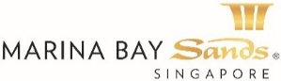 | FURNITURE RENTAL ORDER FORM – 2025  E-mail or fax forms to:  MARINA BAY SANDS PTE LTD – ATTN: SANDS EXPO & CONVENTION CENTRE – CUSTOMER SERVICE CENTRE  10 BAYFRONT AVENUE SINGAPORE 018956  P: +65 6688 3888 F: +65 6688 3889 E: secc@marinabaysands.com  Please indicate total number of pages faxed to ensure complete order was received.
EVENT NAME: ASIA BIO 2025 (83022) |  |  | EVENT DATES: 9-10 SEPTEMBER 2025 |  |  |  | BOOTH # / MTG. ROOM #
 |  |  | HALL LOCATION: L3 CASSIA BALLROOM |  |  |  | BOOTH # / MTG. ROOM #
EXHIBITING CO. NAME:

EXHIBITING CO. ADDRESS: (STREET) |  | (CITY) |  | (STATE) | (COUNTRY) |  | (ZIP CODE)
TELEPHONE: |  | FAX: |  |  |  | E-MAIL:
ORDERED BY: (DR/HON/PROF/MDM/MISS/MRS/MS/MR)  (Print Name) |  | JOB TITLE: |  |  |  | SIGNATURE:
BILL-TO CO. NAME: (If different from above)

BILL-TO ADDRESS: (STREET) |  | (CITY) |  | (STATE) | (COUNTRY) |  | (ZIP CODE)
TELEPHONE: |  | FAX: |  |  |  | E-MAIL:
ORDERED BY: (DR/HON/PROF/MDM/MISS/MRS/MS/MR)  (Print Name) |  | JOB TITLE: |  |  |  | SIGNATURE:
IMPORTANT: TO RECEIVE ADVANCE RATES (UNLESS OTHERWISE STATED) SANDS EVENT SERVICES MUST RECEIVE YOUR ORDER WITH FULL PAYMENT BY 5 PM SGT 14 CALENDAR DAYS PRIOR TO SHOW OPENING DATE TO ENSURE AVAILABILITY. Full payment must be included to receive advance rates, unless otherwise stated. payment received after the cut-off will be invoiced at the standard rate where applicable. ALL OTHER ORDERS WILL BE PROCESSED AT THE STANDARD RATE. NO CREDITS/REFUND WILL BE ISSUED ON SERVICES INSTALLED AS ORDERED EVEN THOUGH NOT USED. ALL ORDERS ARE SUBJECT TO A 7% GST & CANCELLATION FEE. REVIEW INVOICE PRIOR TO DEPARTURE.

DESCRIPTION | QTY | ADVANCED RATE |  | STANDARD RATE |  | SUBTOTAL
CHAIRS
Randy Visitor Arm Chair (Black) |  | $70.00 |  | $115.00
White Chair |  | $90.00 |  | $150.00
Nick Folding Chair (White) |  | $30.00 |  | $50.00
Satellite Chair (MC12W/B) |  | $430.00 |  | $615.00
TABLES
Calvin Discussion Table (White) |  | $90.00 |  | $150.00
Calvin Discussion Table (Black) |  | $90.00 |  | $150.00
Kelly Discussion Table (Black) Dia: 600mm |  | $80.00 |  | $130.00
Kelly Discussion Table (Black) Dia: 800mm |  | $90.00 |  | $150.00
Kelly Discussion Table (White) Dia: 600mm |  | $80.00 |  | $130.00
Kelly Discussion Table (White) Dia: 800mm |  | $90.00 |  | $150.00
Lindi Rectangle Meeting Table (White) 1200mmL |  | $165.00 |  | $275.00
Lindi Rectangle Meeting Table (White) 1500mmL |  | $225.00 |  | 375.00
SOFAS
Arnie Sofa Chair (Black) |  | $80.00 |  | $130.00
Single Seater Sofa – White/ Black (WGS01W/B) |  | $570.00 |  | $815.00
Double Seater Sofa – White/ Black (WGS02W/B) |  | $690.00 |  | $90.00
Otto Cube Ottoman (Black) |  | $90.00 |  | $150.00
Otto Cube Ottoman (White) |  | $90.00 |  | $150.00
COFFE TABLES
Laminate Rectangle Coffee Table (CT05B/WRT) |  | $490.00 |  | $700.00
Dal Coffee Table (Glass) |  | $80.00 |  | $130.00
Comms Coffee Table |  | $90.00 |  | $150.00
HIGH TABLES
Spectra Bistro Table (Black) |  | $70.00 |  | $115.00
Spectra Bistro Table (White) |  | $70.00 |  | $115.00
BARSTOOLS
Iker Stool (Black) |  | $50.00 |  | $90.00
Iker Stool (White) |  | $50.00 |  | $90.00
Gracie Barstool (Black) |  | $80.00 |  | $130.00
Lucie Barstool with Backrest (Black) |  | $90.00 |  | $150.00
Angie Swivel Barstool (White) |  | $90.00 |  | $150.00
DESCRIPTION | QTY | ADVANCED RATE |  | STANDARD RATE |  | SUBTOTAL
MODULAR SYSTEM FURNITURE
Max 2-Tier Counter |  | $150.00 |  | $250.00
Max 3-Tier Counter |  | $435.00 |  | $720.00
Max Reception desk |  | $90.00 |  | $150.00
Max Lockable Cabinet |  | $100.00 |  | $180.00
Max High Lockable Cabinet |  | $115.00 |  | $200.00
Max Curve Counter |  | $375.00 |  | $625.00
Max Display Block 500mmH |  | $90.00 |  | $150.00
Max Display Block 750mmH |  | $100.00 |  | $180.00
Max Display Block 1000mmH |  | $130.00 |  | $200.00
Max High Square Showcase |  | $375.00 |  | $595.00
Max High Square Showcase with lights |  | $400.00 |  | $695.00
Max High Showcase |  | $400.00 |  | $695.00
Max High Showcase with Lights |  | $475.00 |  | $795.00
Max Low Showcase |  | $250.00 |  | $425.00
Max Low Showcase with Lights |  | $375.00 |  | $595.00
Max Folding Door |  | $165.00 |  | $275.00
Max Swing Door |  | $180.00 |  | $300.00
Max System Panel (1000mmW x 2480mmHt) |  | $90.00 |  | $150.00
Max System Panel (500mmW x 2480mmHt) |  | $70.00 |  | $100.00
Max Wall Shelving (Flat) |  | $70.00 |  | $100.00
Max Wall Shelving (Slope) |  | $70.00 |  | $100.00
MISCELLANEOUS
Kool Cube Refrigerator (w/o power point) |  | $315.00 |  | $535.00
Kool Bar Refrigerator (w/o power point) |  | $375.00 |  | $625.00
Kool High Refrigerator (w/o power point) |  | $475.00 |  | $810.00
Viva Easel Stand |  | $80.00 |  | $140.00
Ziggy Foldable Brochure Rack (Black) |  | $130.00 |  | $215.00
Sandi Brochure Rack |  | $100.00 |  | $180.00
Varie Retractable Stanchion Post |  | $70.00 |  | $115.00
Barrie Stanchion Post |  | $70.00 |  | $115.00
Tim Waste Basket |  | $15.00 |  | $20.00
 |  | TOTAL
 |  | PREVAILING GST %
GRAND TOTAL (SINGAPORE DOLLARS)
Price Payable may be subject to change due to impending change in the GST Rate

All orders are subject to a cancellation fee if CANCELLED within 7 calendar days prior to show opening date. All services delivered on site cannot be cancelled nor be refunded. All prices are subject to change without prior notice.

PAYMENT MODE Credit card information will be used to guarantee the service request on this order form. (Will be used for any and all Sands Event Services you order in addition to those listed on this form.)

Cheque No. _________________________ MAKE PAYABLE TO: MARINA BAY SANDS PTE LTD. MUST BE RECEIVED 14 DAYS PRIOR TO EVENT START DATE.
Credit Card Payment:
Please complete and submit the Credit Card Authorization Form.

Cash (only applicable for onsite orders)

Telegraphic Transfer:
Please make payment to:
Bank Name: DBS Bank Ltd
A/C No.: 003-909346-2
A/C Name: Marina Bay Sands Pte Ltd
Swift Code: DBSSSGSG
Reference: Please include the event/event date during Telegraphic Transfer. Failure to do so will result with the wire transfer not properly crediting to your event account.
NOTE: Organization will be responsible for the payment of all charges incurred from the bank.

Cheque Payment:
All cheques should be crossed and made payable to
Marina Bay Sands Pte Ltd

All payments must be sent directly to:
Marina Bay Sands Pte Ltd
Accounts Receivable
Finance Non-Gaming Department
10 Bayfront Avenue
Singapore 018956
Reference: Please include the show name at the back of the
cheque. Failure to do so will result in cheque not properly
crediting to your event account.

Prices, Policies, and Procedures Subject to Change without prior notice. GST Registration No. M90364464

  Randy Visitor Arm Chair  H810 x W430 x D390 |  | 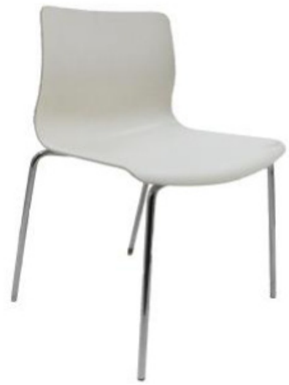  White Chair  H790 x W500 x D500 |  | 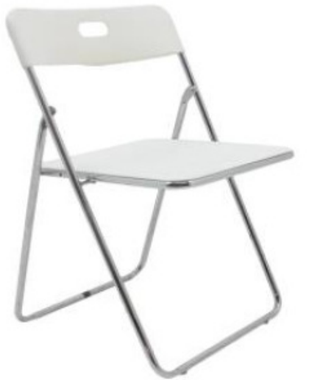  Nick Folding Chair  H800 x W400 x D400
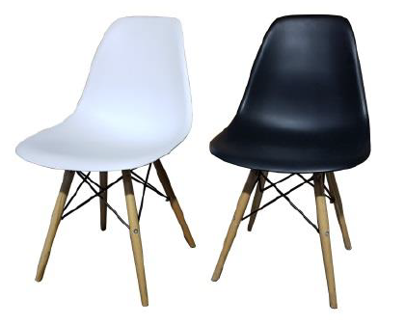  Satellite Chair (MC12W/B)  H800 x W550 x D460 |  | 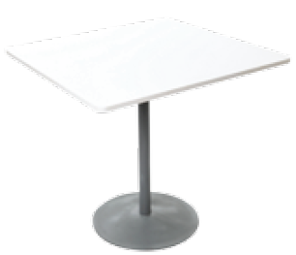  Calvin Discussion Table  H740 x W800 x D800 |  | 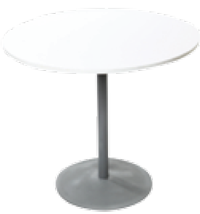  KELLY Discussion Table – 800mmDia  H740 x W800 x D800
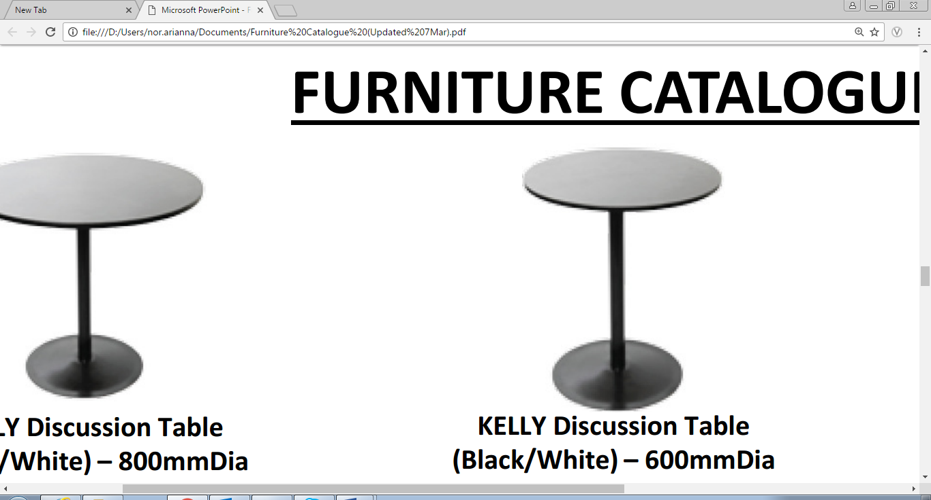  KELLY Discussion Table – 600mmDia  H740 x W600 x D600 |  | 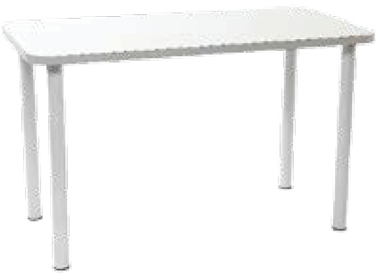  Lindi Rectangular Meeting Table  H750 x W1500 x D700 |  |   Arnie Sofa Chair  H630 x W630 x D630
  Single Seater Sofa – White/ Black (WGS01)  H850 x W770 x D750 | 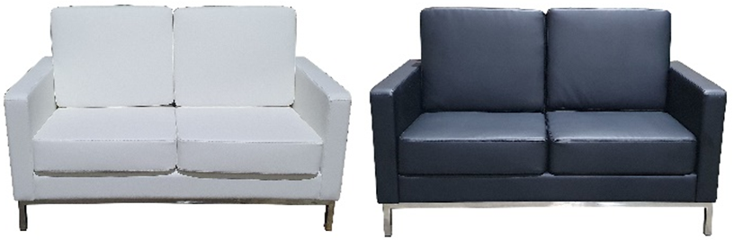  Double Seater Sofa – White/ Black (WGS02)  H850 x W1340 x D750 |  |  |  | 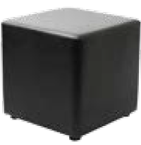  Otto Cube Ottoman  H500 x W500 x D500
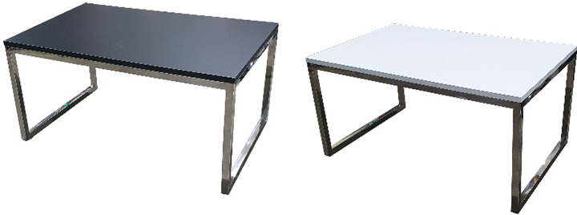  Laminate Rectangle Coffee Table (CT05B/WRT)  H455 x W900 x D570 |  |  | 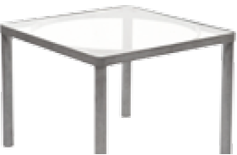  Dal Coffee Table  H400 x W550 x D550 | 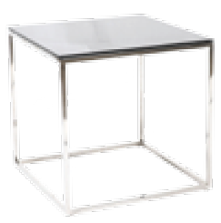  Comms Coffee Table  H400 x W400 x D400

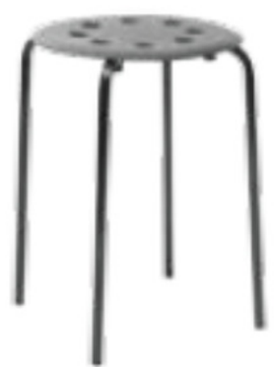  IKER Stool  H500 x W300 x D300 |   Gracie Barstool  H790 x W340 x D340 | 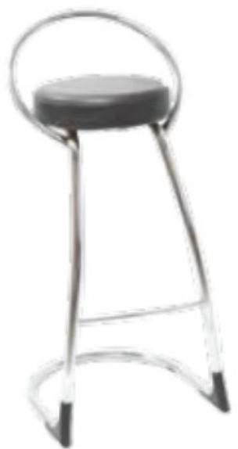  LUCIE Round Barstool with Backrest  H800 x W400 x D400
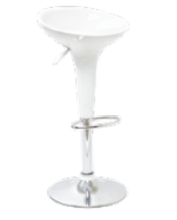  ANGIE Swivel Barstool (White)  H790 x W500 x D500 | 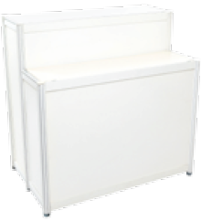  Max 2-Tier Counter  H750/H1000 x W1000 x D300 | 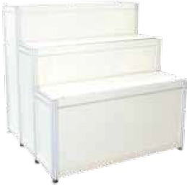  Max 3-Tier Counter  H500/ H750/ H1000 x W1000 x D300
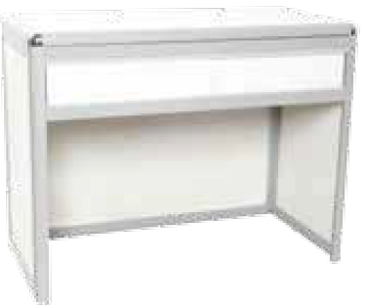  Max Reception Counter  H750 x W1000 x D500 | 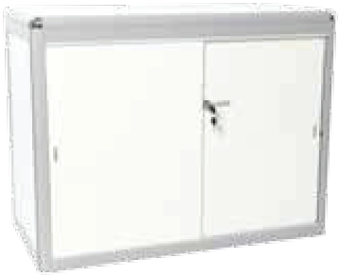  Max Lockable Cabinet  H750 x W980 x D480 | 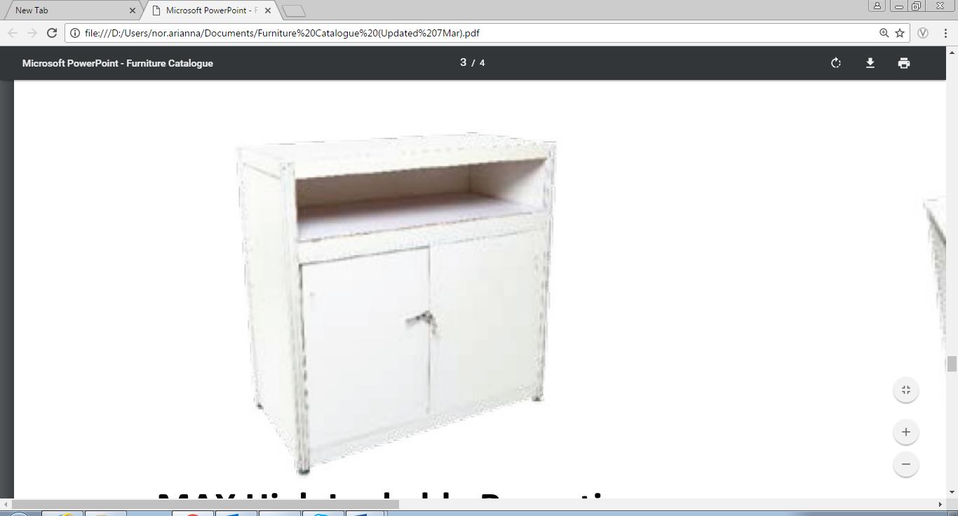  Max High Lockable Cabinet  H1000 x W1000 x D500
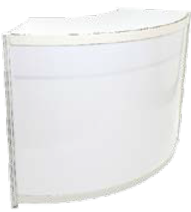  Max Curve Counter  H1000 x W1980 x D450 | 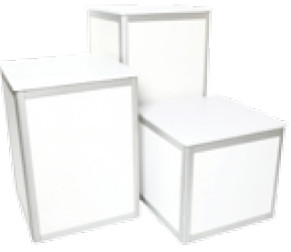  Max Display Block  H500/ H750/ H1000 x W500 X D500 | 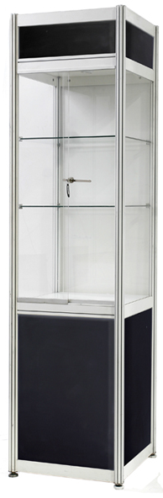  Max High Square Showcase  H2000 x W500 x D500
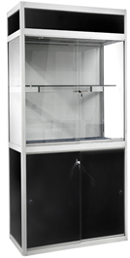  Max High Showcase  H2000 x W1000 x D500 | 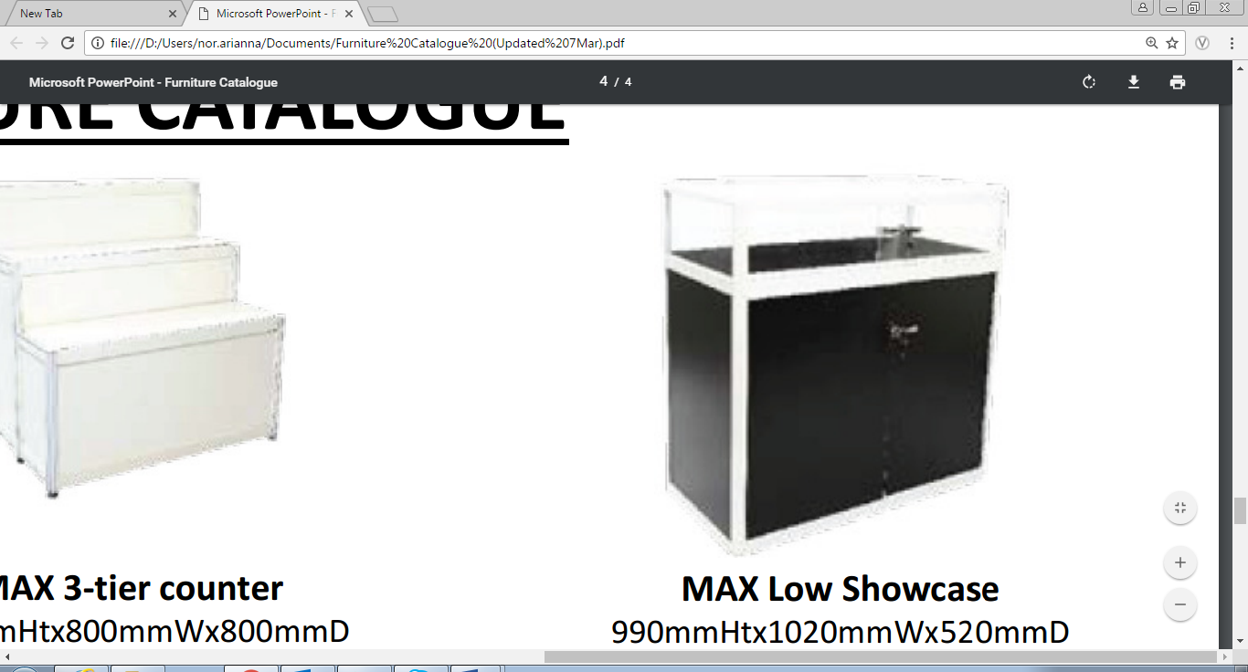  Max Low Showcase  H1000 x W1000 x D500 | 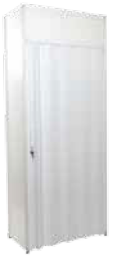  Max Folding Door  H2500 x W1210

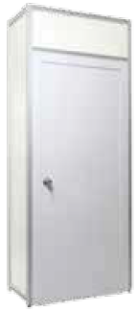  Max Swing Door  H2500 x W1000 |   Max Wall Shelving (Fat/Slope)  H20 x W950 x D300 | 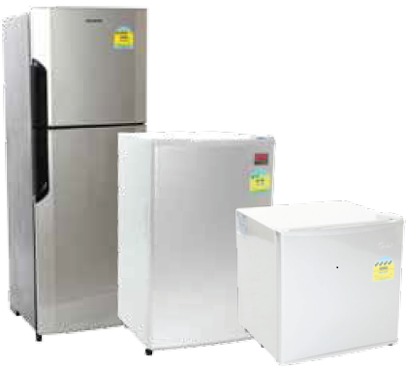  Kool Refrigerator  H1455 W525 x D525  H830 x W480 x D460  H495 x W470 x D435
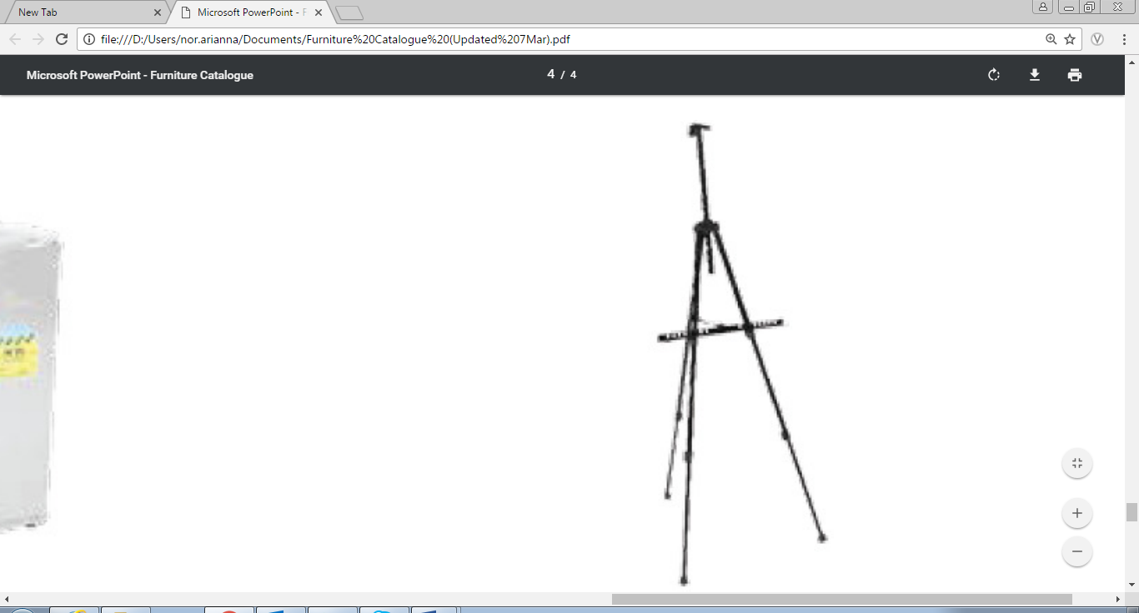  VIVA Easel Stand  H1500 x W700 x D700 | 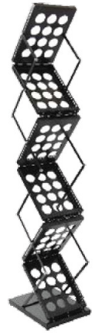  ZIGGY Foldable Brochure Rack  H1600 x W275 x D365 | 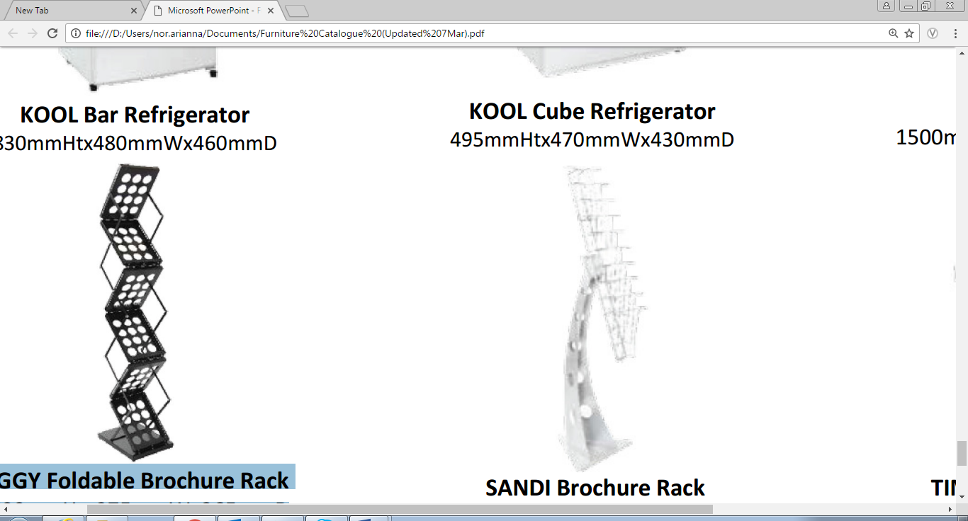  SANDI Brochure Rack  H1500 x W430 x D700
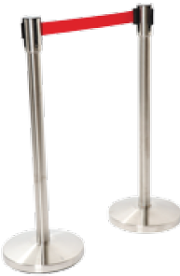  Varie Station Post  H900 x W300 x D500 |   Barrie Stanchion Post  H900 x W300 x D500 |   Tim Waste Basket  H300 x W290 x D290

LAST DAY TO RECEIVE ADVANCE RATE IS 26 AUGUST 2025
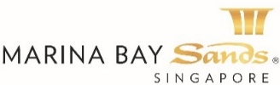 | EXHIBITION LIGHTINGS AND APPLIANCE ORDER FORM – 2025  FORM 12i  E-mail or fax forms to:  MARINA BAY SANDS PTE LTD – ATTN: SANDS EXPO & CONVENTION CENTRE – CUSTOMER SERVICE CENTRE  10 BAYFRONT AVENUE SINGAPORE 018956 P: +65 6688 3888 F: +65 6688 3889  E: secc@marinabaysands.com  Please indicate total number of pages faxed to ensure complete order was received.

EVENT NAME: ASIA BIO 2025 (83022) |  | EVENT DATES: 9-10 SEPTEMBER 2025 |  |  |  | BOOTH # / MTG. ROOM #
 |  | HALL LOCATION: L3 CASSIA BALLROOM |  |  |  | BOOTH # / MTG. ROOM #
EXHIBITING CO. NAME:

EXHIBITING CO. ADDRESS: (STREET) | (CITY) |  | (STATE) | (COUNTRY) |  | (ZIP CODE)
TELEPHONE: | FAX: |  |  |  | E-MAIL:
ORDERED BY: (DR/HON/PROF/MDM/MISS/MRS/MS/MR)  (Print Name) | JOB TITLE: |  |  |  | SIGNATURE:
BILL-TO CO. NAME: (If different from above)

BILL-TO ADDRESS: (STREET) | (CITY) |  | (STATE) | (COUNTRY) |  | (ZIP CODE)
TELEPHONE: | FAX: |  |  |  | E-MAIL:
ORDERED BY: (DR/HON/PROF/MDM/MISS/MRS/MS/MR)  (Print Name) | JOB TITLE: |  |  |  | SIGNATURE:

DESCRIPTION | QTY |  | ADVANCED RATE | STANDARD RATE | SUBTOTAL
Fluorescent Light |  |  | $70 | $110
Spotlight |  |  | $80 | $130
Arm Spotlight |  |  | $90 | $150
Eyeball Downlight 100W (hole opening 5”) |  |  | $70 | $110
Halogen Spotlight 12V |  |  | $80 | $130
Arm Halogen Spotlight 12V |  |  | $100 | $175
Arm Halogen Chrome Light |  |  | $115 | $190
Chrome arm Halogen Light ( not for system wall ) |  |  | $115 | $190
Halogen Downlight 12V ( hole opening 3”) |  |  | $100 | $175
Track Spotlight |  |  | $50 | $90
Track Halogen Spotlight 12V |  |  | $80 | $130
Floodlight 150W |  |  | $115 | $190
Floodlight 300W |  |  | $195 | $330
Floodlight 500W |  |  | $225 | $380
70W Metal Halide |  |  | $190 | $320
150W Metal Halide |  |  | $240 | $400
70W Arm Metal Halide |  |  | $225 | $380
70W Recess Metal Halide |  |  | $225 | $380
150W Recess Metal Halide |  |  | $240 | $400
70W Track Metal Halide |  |  | $190 | $320
LED Light connection per 3m run |  |  | $70 | $115
Arm Floodlight 150W |  |  | $130 | $215
Arm Floodlight 300W |  |  | $215 | $360
Arm Floodlight 500W |  |  | $300 | $500
Connection - 100W (per fitting) |  |  | $75 | $120
Connection - 300W (per fitting) |  |  | $150 | $260
Connection - 500W (per fitting) |  |  | $195 | $330
Light Box Connection-5 Amp (up to 9x 40watt fluorescent light) |  |  | $180 | $295
13 Amp/ 230V Single Phase Power point (not for lighting) |  |  | $75 | $125
16 Amp/ 230V Single Phase Power point (not for lighting) |  |  | $150 | $260
16 Amp/ 415V 3 Phase Power point (not for lighting) |  |  | $495 | $835
32 Amp/ 415V 3 Phase Power point (not for lighting) |  |  | $1,140 | $1,915
63 Amp/ 415V 3 Phase Power point (not for lighting) |  |  | $2,225 | $3,740
**Service required for 24-HOUR POWER. DOUBLE THE APPLICABLE RATE |  |  |  | TOTAL
 |  |  |  | PREVAILING GST %
GRAND TOTAL (SINGAPORE DOLLARS)
Price Payable may be subject to change due to impending change in the GST Rate
All orders are subject to a cancellation fee if CANCELLED within 7 calendar days prior to show opening date. All services delivered on site cannot be cancelled nor be refunded. All prices are subject to change without prior notice.

PAYMENT MODE Credit card information will be used to guarantee the service request on this order form. (Will be used for any and all Sands Event Services you order in addition to those listed on this form.)
Cheque No./Telegraphic Transfer No. _________________________ MAKE PAYABLE TO: MARINA BAY SANDS PTE LTD. MUST BE RECEIVED 14 DAYS PRIOR TO EVENT START DATE.
Telegraphic Transfer:
Please make payment to:
Bank Name: DBS Bank Ltd
A/C No.: 003-909346-2
A/C Name: Marina Bay Sands Pte Ltd
Swift Code: DBSSSGSG
Reference: Please include the event/event date during Telegraphic Transfer. Failure to do so will result with the wire transfer not properly crediting to your event account.
NOTE: Organization will be responsible for the payment of all charges incurred from the bank.

Credit Card Payment:
Please complete and submit the Credit Card Authorization Form.

Cash (only applicable for onsite orders)

Cheque Payment:
All cheques should be crossed and made payable to
Marina Bay Sands Pte Ltd

All payments must be sent directly to:
Marina Bay Sands Pte Ltd
Accounts Receivable
Finance Non-Gaming Department
10 Bayfront Avenue Singapore 018956
Reference: Please include the show name at the back of the
cheque. Failure to do so will result in cheque not properly
crediting to your event account.
Prices, Policies, and Procedures Subject to Change without prior notice. GST Registration No. M90364464C

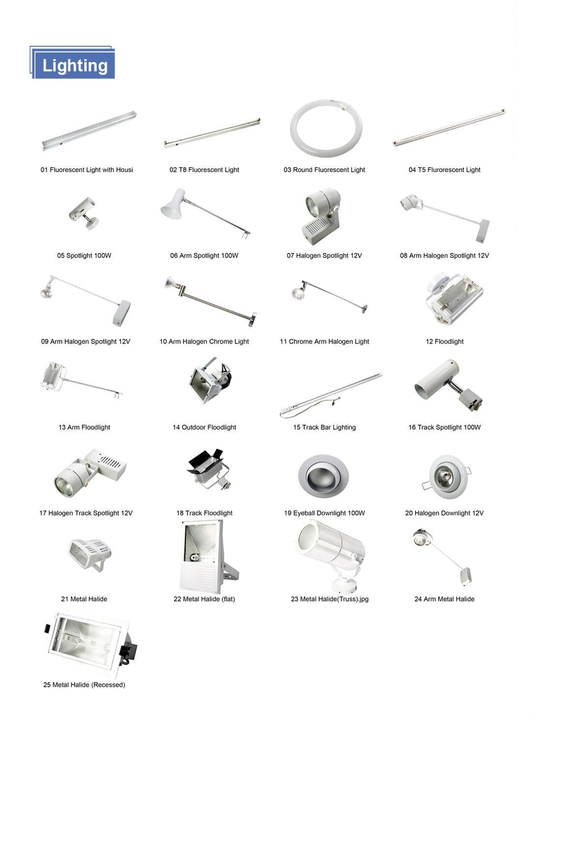

PERFORMANCE BOND MUST BE RECEIVED BY: 29 JULY 2025
Performance Bond Form – Stand Arranged by Exhibitor
E-mail or fax forms to:
MARINA BAY SANDS PTE LTD – ATTN: SANDS EXPO & CONVENTION CENTRE – CUSTOMER SERVICE CENTRE
10 BAYFRONT AVENUE SINGAPORE 018956
P: +65 6688 3888 F: +65 6688 3889 E: secc@marinabaysands.com
Please indicate total number of pages faxed to ensure complete order was received.

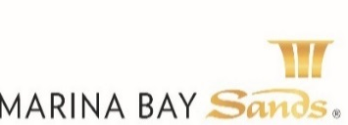

This form is applicable to exhibitors who have contracted for SPACE ONLY and will be engaging their own stand fitting contractor or are building their own stands.
- In adherence to safety requirements, only the Organiser’s official contractor may carry out electrical & pipe installations. Exhibitors may appoint their own contractor for stand design and/or construction subject to them being approved by the organiser. All approved contractors must lodge a refundable deposit equivalent to SGD 100 per square meter based on contracted space, subject to a minimum of SGD 1000 and maximum of SGD 5000 per booth.
- This is to ensure that the rules & regulations are abided by and to cover all damages arising directly or indirectly from any infringement. This is without prejudice to any additional claim the organiser may have on the contractor and/or exhibitor if the damages exceed the deposit.
This form must be jointly signed by the exhibitor and the appointed stand fitting contractor

Stand fitting Contractor Company Name:
EVENT NAME: ASIA BIO 2025 (83022) |  | EVENT DATES: 9-10 SEPTEMBER 2025 |  | BOOTH # / MTG. ROOM #
EVENT LOCATION: |  | HALL LOCATION: L3 CASSIA BALLROOM |  | BOOTH # / MTG. ROOM #
STREET ADDRESS: | CITY: |  | STATE: | ZIP CODE:
TELEPHONE: | FAX: |  | E-MAIL:
ORDERED BY: (DR/HON/PROF/MDM/MISS/MRS/MS/MR)  (Print Name) | JOB TITLE: |  | SIGNATURE:

- We enclose herewith detailed drawings (elevations, layout plans & perspective views) with dimensions and heights, illustrating the design of our stand for the exhibition. Relative locations of all equipment/machinery on display are also depicted on the layout.
- We, the exhibitor and contractor, agree to abide by all Rules & Regulations (including those for double-storey exhibition stands) of the exhibition, as well as the code of practices set by the relevant Regulatory Authorities.
EXHIBITING COMPANY NAME: |  |  |  |  | PERSON IN CHARGE (PRINT NAME):
STREET ADDRESS: |  |  | CITY: |  | STATE: |  |  |  |  | ZIP:
TELEPHONE: |  |  | FAX: |  | E-MAIL:
Item Description |  |  |  |  |  | SQM |  | Unit Rate |  |  | Subtotal
Performance Bond (Minimum of SGD 1000; Maximum of SGD 5000 per booth) |  |  |  |  |  |  |  | S$100 per sqm
 |  |  |  |  |  | GRAND TOTAL
Cheque Payment: All cheques should be crossed and made payable to ‘Marina Bay Sands Pte Ltd’. All payments must be sent directly to:
Marina Bay Sands Pte Ltd: Sands Expo & Convention Centre – Customer Service Centre, 10 Bayfront Avenue Singapore 018956. Reference: Please include the show name and booth number at the back of the cheque. Failure to do so will result in cheque not properly crediting to your event account.

Cheque No. _________________________ MAKE PAYABLE TO: MARINA BAY SANDS PTE LTD. MUST BE RECEIVED 14 DAYS PRIOR TO EVENT START DATE.

Credit Card Payment: Please complete and submit the Credit Card Authorization Form.

ACKNOWLEDGEMENT RECEIPT

Performance Bond Received from:
(Contractor)___________________________________ Cheque Number: ______________________________
Performance Bond Receipt Date: __________________
This is an acknowledgement that the performance bond has been received from staff of Marina Bay Sands Pte Ltd:

(TM Name)___________________________________ (Signature) ____________________________________

Prices, Policies, and Procedures Subject to Change without prior notice. GST Registration No. M90364464C

Rules & Regulations for Stand Construction

Observance of Rules and Regulations
Exhibitors are responsible for their contractor’s observance of all rules and regulations, and are liable for any damages arising directly or indirectly from any infringement.

Identification
All workers employed in the construction of the stand must wear identification badges provided by the organizer at all times when they are in the exhibition halls. Personnel without proper badges will be refused entry into the exhibition halls.

Removal of Rubbish
During the build-up period, exhibitors and their contractors will be responsible for day-to-day removal of debris (i.e. empty paint cans, lumber scraps, etc.) Failure to do so will result in the exhibitors being liable for the service fees involved in removing the debris.

Building Regulations
To comply with local building regulations, detailed drawings of stands must be submitted to the organizer by the stipulated deadline for the approval of the relevant government authorities and the organizer to ensure that the interests of all the exhibitors are observed.
The exhibiting company and their appointed contractor(s) shall ensure the structural integrity of their booth design.

Hall Structure
In the construction of the booth, existing fixtures or walls may not be used in any way (e.g. nailing, wiring or fixing of items to any existing structure).

Work Schedule
Exhibitors and their appointed contractors must strictly adhere to the schedule given by the organiser.
In accordance with the organiser’s build-up schedule, carpet and main structures must be installed within 24 hours of the commencement date.
Failure to comply with these regulations may result in the delay of installation of electrics and equipment move-in, and any consequential costs incurred will be charged to the exhibitor.

Fire Regulations/Covered Ceilings
All materials used in the stand construction must be fire-retardant in accordance with local regulations, i.e. a minimum flame spread rating of class 2.
Approval for covered ceilings in exhibition stands must be sought from the Fire Safety & Shelter Department through the organiser, and plans and sample of material with certificate must be submitted at least two months prior to the exhibition. Late submission will not be accommodated.

Floor covering
All booths must be carpeted or laid with some form of flooring as clear demarcation of contracted space. All carpet and floor covering must be affixed with double-sided tapes. These tapes are to be removed during the dismantling period. The use of paint or other adhesives on the floor of the exhibition hall is strictly forbidden. Timber underlays of minimum 15mm must be provided for booth that are erected in existing carpeted areas of meeting rooms, ballrooms and common corridors.

Backwall/Sidewalls
With the exception of “island” (4-side open) booths, a backwall must be installed for every booth. Booth with adjoining neighbor(s) must also be installed with the necessary sidewall(s).

Height Restriction
The permitted stand height is 2.44m (8ft). Any design for a structure exceeding 2.44m in height must be submitted for approval at least 8 weeks in advance and will be considered on a case-to-case basis. If approved, such structure will be restricted to a distance of 1 metre (3.28ft) away from the dividing walls of the adjoining stands. This restriction also applies to overhead structure suspended from the existing hall ceilings.

Open Frontage
All stands in the exhibition, irrespective of height, must have at least half of any frontage facing an aisle left open, or fitted with transparent (clear see-through) material. This area must be left visibly free of obstruction.

Dismantling
At the close of the exhibition, it is the joint responsibility of the exhibitor and contractor to dismantle and remove the stand in accordance with the dismantling schedule specified by the organizer. All debris and carpets must be cleared by the exhibitors and/or their contractors as per the tear-down schedule given by the organizer. Failure to do so will result in the contractors/exhibitors being liable for service fees incurred.

Unforeseen Occurrences
In the event of any occurrence not foreseen in these Rules & Regulations, the decision of the organizer shall be final.

Prices, Policies, and Procedures Subject to Change without prior notice. GST Registration No. M90364464C

Additional Rules & Regulations for Double Storey Stand Construction

- The exhibitor of the lower level of a particular booth must be the same as that of the upper level.
- Double storey booth will only be allowed provided the minimum contracted floor area for the lower level of the particular booth is 60 square metres and that the minimum length of any dimensions of the area is 6 metres.
- The contracted floor area at the upper level shall not exceed 50% of the contracted floor area at the lower level of the particular booth.
- Any additional cost incurred in extending the build-up/tear-down period will be fully borne by the exhibitor.
- Subject to the ceiling height limitations, all objects exceeding 2.44metres in height must be placed at a minimum distance of 1 metre from all boundaries adjoining a neighboring booth.
- The permissible occupant load of the upper floor shall be based on the ration of one person to 1.5metre square. A notice in 25mm plain block letters indicating the limitation of occupant load should be conspicuously positioned at the head & foot of the staircase.
- All booth designs and construction must comply with the guidelines, rules and regulations laid down by the relevant government authorities, as well as both the organiser’s and the exhibition hall owner’s requirements.
- Stand designs and layout plans must be submitted to the organizer at least 3 months prior to the exhibition. The exhibiting company and their appointed contractor must submit in quadruplicate the detailed drawings (to scale in 1:200) with endorsement from a local qualified engineer together with the structural calculations of the proposed stand design. The exhibitor or appointed contractor must submit the detailed drawings and endorsement to the Fire Safety & Shelter Department for comments / approval. More details can be obtained at www.scdf.gov.sg
- A copy of the approval letter from Fire Safety & Shelter Department must be submitted to the Organizer 2 weeks prior to the exhibition. Only upon approval from all relevant authorities can the exhibiting company commence work on-site.
- The booth must be constructed in accordance with the approved design and be ready within the build-up period specified by the organizer.
- The exhibitor shall ensure that the booth is dismantled in a safe, systematic and organized manner; within specified dismantling period.
- With regards to other issues in general, the rules and regulations stipulated in this Technical Services Manual are still to be complied with.

Prices, Policies, and Procedures Subject to Change without prior notice. GST Registration No. M90364464C

