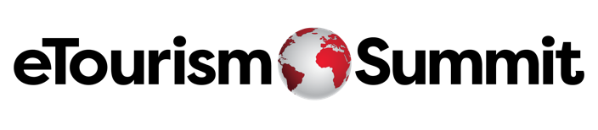

Copy and paste the information below, and share it with your boss (or even if you are boss).

Dear (Manager’s name),

With the eTourism Summit 2025 registration now open, I am writing to request approval to attend the 26th annual event from April 22-24, 2025, in Las Vegas, NV. Given the immense value and unique opportunities this event presents for the tourism industry, I believe it is an educational investment that will greatly benefit our marketing team and organization.

Since its inception, the eTourism Summit has been a community of forward-thinking marketers, a hub for exchanging groundbreaking ideas in an intimate setting, and a visionary space where the travel industry reimagines the future of tourism. The peer-to-peer learning format sets eTS apart and offers a perfect blend of learning and networking. Attendees range from experienced digital marketers sharing their expertise to those acquiring new knowledge, along with the vendors who make it all happen. It is an ideal setting for me to gain insights from industry peers and bring back innovative strategies to enhance our marketing efforts.

The cost to attend the 2025 eTourism Summit is $1,795, and it represents a valuable investment in our organization’s growth and success. This fee covers access to a comprehensive agenda filled with cutting-edge sessions on AI, Data, Sustainability, EDI, Leadership Skills, and Social Media Marketing, presented by industry leaders and successful DMOs. This content is exclusive and cannot simply be Googled, ensuring that our organization will access fresh, actionable insights directly from the best of the best.

Additionally, the eTSY Awards, which celebrate excellence in tourism marketing, will take place in person at the event. We have the exciting opportunity to compete and potentially win, further enhancing our reputation and credibility in the industry. Last but certainly not least, it is essential that we stay ahead of emerging trends and innovations, and eTourism is platform to do it.

As the premier gathering for DMO marketers and travel industry suppliers, eTourism Summit is the place to "See Tomorrow, Together." I firmly believe that attending the eTourism Summit will provide us with invaluable knowledge and networking opportunities, helping us stay ahead in the ever-evolving travel industry.

I kindly request your approval for this professional development opportunity. Thank you for considering my request. Please let me know if you need any further information.

Best,
(Your Name)

