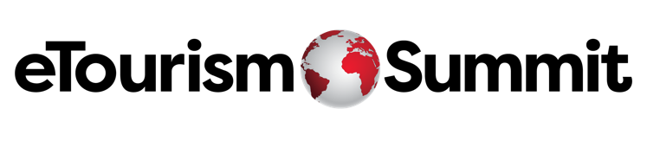

Copy and paste the information below, and share it with your boss (or even if you are boss).

Dear (Manager’s name),

I am reaching out to discuss the possibility of attending the eTourism Summit 2025. For 26 years, this premier event has been a cornerstone for top travel industry suppliers and leading destination marketers, offering 2.5 days of unparalleled thought leadership, peer-to-peer learning, and invaluable networking opportunities. The upcoming eTourism Summit will be held from April 22-24, 2025, in Las Vegas, NV, and I truly believe our attendance could significantly benefit our company.

**Why Attend eTourism Summit?**

* **Substantial ROI:** The $4,950 registration fee is an investment that offers a significant return, with the potential to accomplish a year’s worth of business in just 2.5 days. The insights and connections gained can pay for the fee many times over.
* **Competitive Edge:** Our competition will be there. By attending, we stay ahead of industry trends and technologies, showcasing our commitment to innovation and excellence. It’s a vital opportunity to distinguish ourselves from competitors.
* **Unmatched Networking:** eTS gathers hundreds of DMO leaders from across North America, offering direct access to key decision-makers and industry leaders. These high-quality connections can drive business growth and foster new partnerships.
* **Thought Leadership:**The event features sessions with top industry minds, delivering cutting-edge tools and insights to elevate marketing strategies. eTourism prides itself on sharing exclusive content that can't be found through a simple Google search. By learning from successful DMO case studies and hearing directly from marketers, they stay competitive and innovative, gaining valuable insights into what marketers seek in their partnerships.

Attending the eTourism Summit 2025 aligns perfectly with our strategic goals and offers a substantial opportunity for accelerating our business in the travel industry. The thought leadership, networking, and competitive insights gained from this event will equip us with the knowledge and connections needed to drive significant business growth and innovation in the tourism marketing industry.

I strongly believe that our participation at eTourism Summit will be a high value investment: and provide us with the tools and intelligence to stay ahead in the competitive landscape of destination marketing.

Thank you for considering my request. I look forward to discussing this further and answering any questions you may have.

Best,

(Your Name)