Nordic Financial Crime & Sanctions Forum 2025 Prize Draw
Enter this year’s networking competition for a chance to win a £350 flight voucher.
- Go to the Dashboard in this app, and click the 'Scanner'.

- Visit the sponsor exhibition stands in the exhibition hall (onsite) at the conference. Use this scanner to scan QR codes displayed on sponsors' exhibition stands.

- Scan your fellow delegates details using the ‘Scanner’ application - the more delegates you scan, the higher your chances of winning!

- Scan every exhibition stand's code and as many other delegates as possible to be in with a chance of winning a £350 flight voucher.

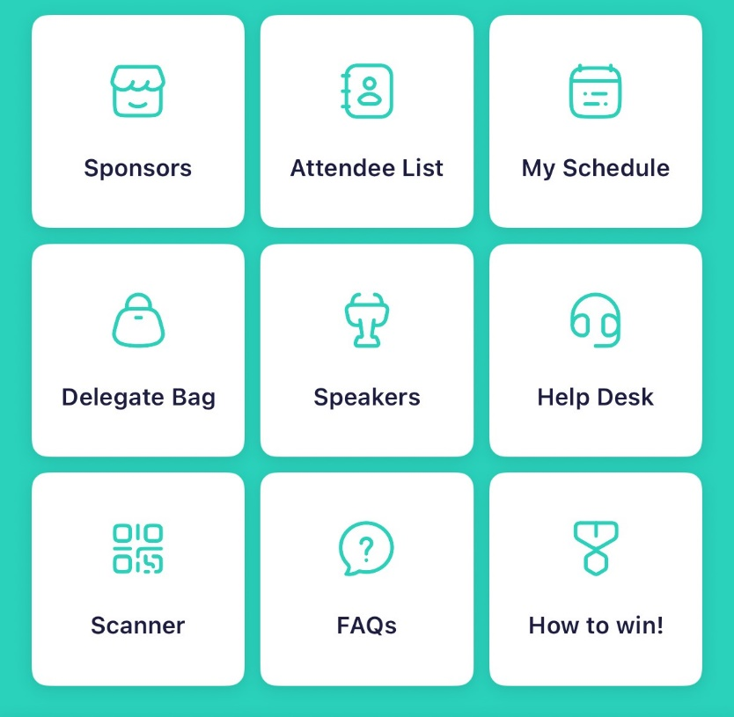

Official Rules
NO PURCHASE NECESSARY TO ENTER OR WIN.
ELIGIBILITY: £350 flight voucher Prize Draw (“Prize Draw”) is open to attendees of the Global Sanctions Forum, scheduled on 16th & 17th September 2025 at the Crowne Plaza Copenhagen Towers, Denmark (“Event”).
TO ENTER: To enter, scan the sponsor QR codes displayed at each exhibition stand in the Event's official networking area and scan as many other delegates as possible at the Crowne Plaza Copenhagen Towers. Entries must be submitted by the end of the final break on the day of the Event. Limit one (1) entry per person. Multiple entries from any person will be void.
WINNER SELECTION AND NOTIFICATION: A winner will be selected in a random drawing conducted at the end of the day during the Event, from all eligible entries received. The winner will be announced at the Event immediately following the drawing. Odds of winning depend on the number of eligible entries received. The potential winner must be present on-site at the conference at the time of the drawing to claim the prize. If the potential winner is not present or is found to be in violation of these Official Rules, he/she will be disqualified, and, at the organiser’s discretion, an alternative winner may be selected.
PRIZE: £350 flight voucher. Approximate Retail Value (“ARV”): £350.00. Any costs and expenses associated with prize acceptance and use not specified herein as being provided are winner’s responsibility. No transfer, cash equivalent or substitution of prize is available. Prize will be awarded “as is” with no warranty or guarantee, either express or implied. All prize details are at the organiser’s sole discretion.
SURVEY CONTACT DETAILS USAGE: The contact details submitted by entrants may be used by Event Sponsors for possible follow-up and/or to initiate a conversation with the potential contact.
GENERAL TERMS & CONDITIONS: By entering, entrants agree to be bound by these Official Rules and decisions of the Organiser, which are final and binding in all matters. Released Parties are not responsible for late, incomplete or undelivered entries; or for errors or difficulties of any kind whether human, mechanical, typographical, printing or otherwise relating to or in connection with the Prize Draw, including, without limitation, errors or difficulties which may occur in connection with the administration of the Prize Draw, the processing of entries, the announcement of the prize or in any Prize Draw-related materials. If, for any reason, the Prize Draw is not capable of running as planned, including disruptions caused by tampering, unauthorized intervention, fraud or any other cause that affects or compromises the administration, security, fairness, integrity, proper conduct or intended play of the Prize Draw, the Organiser reserves the right at its sole discretion to disqualify any individual deemed responsible and void all associated entries. The Organiser further reserves the right to cancel, terminate, modify or suspend the Prize Draw and, if terminated, to randomly select winner from all non-suspect, eligible entries received as of such action that are unaffected by the problem. Prize Draw materials and entries void if incomplete, not legible, or if they contain errors or obtained through illegitimate channels. By participating, entrants agree release and hold harmless Released Parties from and against any and all claims or liability that may arise, in whole or in part, directly or indirectly, in connection with their participation in this Prize Draw or the acceptance or use of any the prize awarded.
USE OF DATA: Sponsor will be collecting personal data about entrants, in accordance with its privacy policy. Please review the Organiser’s privacy policy at: https://www.informa.com/privacy-policy/
ORGANISER: Informa Connect, 5 Howick Place, London, SW1P 1WG, UK.

