Sample Risk Assessment Template

Identified Hazard | Outcome | Who is at Risk? | Pre-Control Risk Level  Likelihood x Impact | Applied Controls | Post Controls Risk  Likelihood x Impact L x I = R (new risk level)
- Slipping/Tripping hazards (e.g. poorly maintained floors or stairs)  - Fire (e.g. from flammable materials)  - Chemicals & Hazardous substances (e.g. cleaning fluids)  - Moving parts of machinery (e.g. blades)  - Working at height above 2.5m (e.g. platforms, etc)  - Vehicles  - Electricity (e.g. wiring)  - Temperatures  etc | First aid injury – minor cuts, sprains, bruises  Up to 3 days injury – broken fingers, toes, sprained tendons or muscles, illness  Serious injury – head injury, loss of consciousness, broken bones, dislocations, respiratory problems. Usually an injury from which full recovery is possible.  Death or very serious injury to one person – Loss of limb, paralysis or life changing injury from which full recovery is unlikely.  Death or very serious injury to more than one person. | Occupation:  Contractors  Venue staff  Exhibitors  Visitors, etc  Number: | Likelihood (L) *  Impact (I) **  Calculation of Risk (R)  L = (Low Risk)  M = (Medium Risk)  H = (High Risk)  C = (Critical Risk)  * The likelihood of the accident happening  ** The consequence of the accident | Use the hierarchy of controls  - Eliminate  - Replace  - Isolate  - Procedure  - PPE | What is Residual Risk?  The level of risk left over after the required controls have been implemented and are judged to be working as intended.  Action level  C = Critical  Activity should not proceed  H = High  immediate action /  further controls needed  M = Medium  For Mgt acceptance / justify / review for each event day  L = Low  no further action  required. Monitor only
  5 | Almost certain
  4 | Likely
  3 | Possible
  2 | Unlikely
  1 | Rare
  5 | Critical - Multiple deaths or very serious injury, unable to continue operations indefinitely
  4 | Major - Single death or very serious injury  3 days more
  3 | Moderate - Serious injury Up to 1-3 days
  2 | Minor – Multiple minor injuries requiring first aid  1 day injury
  1 | Small - Minor/First Aid  Injury person able to continue with task post incident
   | 5 | 5.M |  | 10.M |  | 15.H |  | 20.C |  | 25.C
   | 4 | 4.L |  | 8.M |  | 12.H |  | 16.H |  | 20.C
   | 3 | 3.L |  | 6.M |  | 9.M |  | 12.H |  | 15.H
   | 2 | 2.L |  | 4.L |  | 6.M |  | 8.M |  | 10.M
  L | 1 | 1.L |  | 2.L |  | 3.L |  | 4.L |  | 5.M
   | I | 1 |  | 2 |  | 3 |  | 4 |  | 5

Identified Hazard | Outcome | Who is at Risk? | Pre-Control Risk Level  Likelihood x Impact | Applied Controls | Post Controls Risk  Likelihood x Impact L x I = R (new risk level)
Occupation:

Number:

Risks to be monitored each day as follows: (Normally those risks rated “medium” after controls are in place)

Hazard | Monitored by | Frequency

Assessment by: (Person from Contracting Company) (Job Title)

Contracting Company Name Date

Risk Assessment For (Exhibiting Company): Stand no.

Risk Rating

**Risk Rating = Likelihood x Impact

e.g. Likelihood – Possible; Impact Scale – 3 (Moderate) ➔ Risk Rating 3 x 3 = Medium

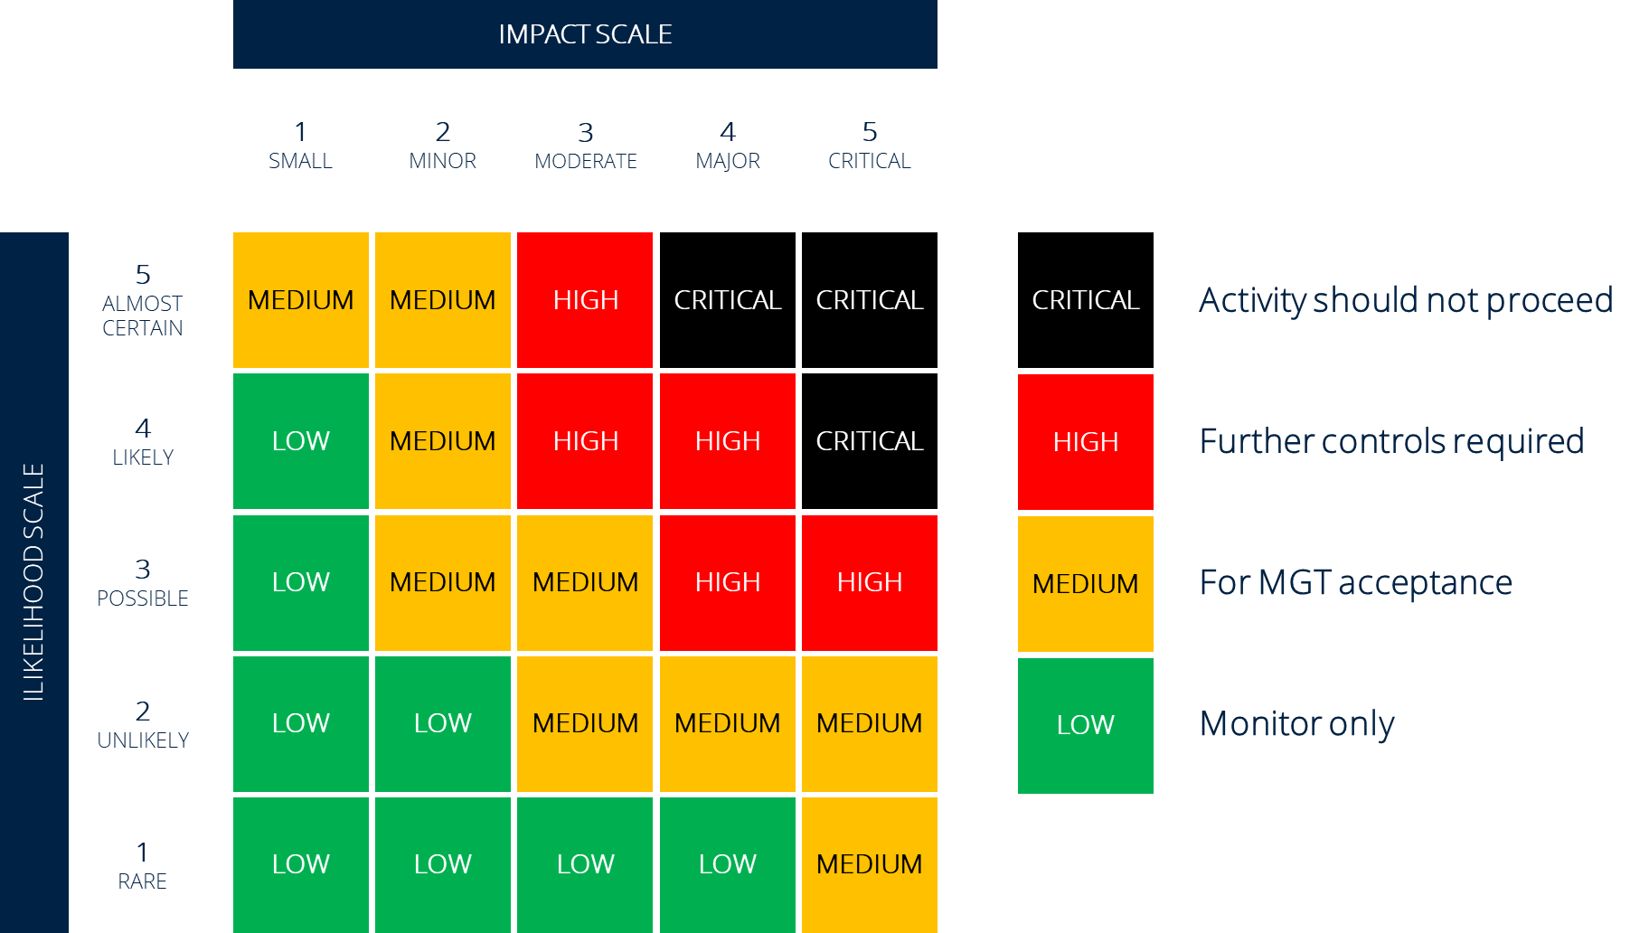
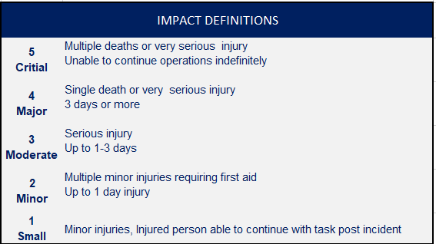
LIKELIHOOD SCALE

