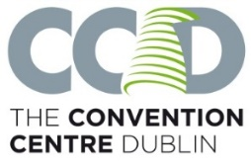

Please provide the following information and attach this sheet to all deliveries being delivered to The CCD after your event. We have limited storage facilities in The CCD therefore, we can only accept deliveries 72 hours before your event.

|  |  |
| --- | --- |
| Name and date of event | Cell and Gene Therapy Manufacturing & Commercialization Europe |
| Level and room name of event | Floor 1 – The Liffey A&B |
| Who are you delivering to? Please give the name of your Event Delivery Manager at The CCD. | Billy Kilkenny |
| Address | The Convention Centre Dublin,  Spencer Dock,  North Wall Quay,  Dublin 1,  D01 T1W6. |
| Exhibitor contact name and number |  |
| Exhibitor stand name and number |  |
| Insert your courier name and expected arrival date |  |

Item number ______ of _____